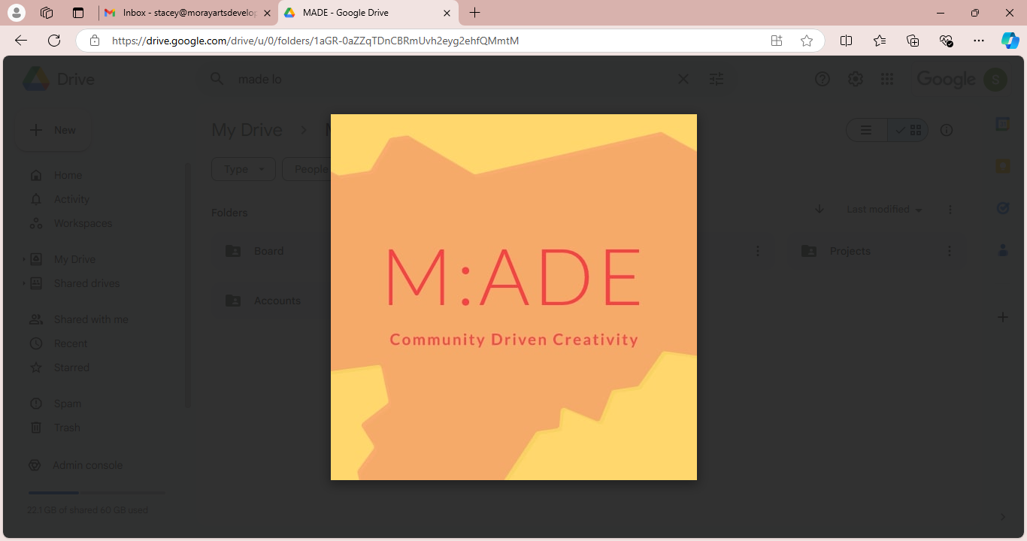

www.morayartsdevelopmentengagement.org

MADE for YOU: Creative Bursaries
KEY INFORMATION

MADE for YOU is a creative bursary scheme for artists and practitioners living in Moray. These awards are supported by the Creative Scotland Open Fund, facilitated by MADE in our commitment to supporting creative and cultural individuals in the region. The bursaries are open to individuals that identify as creatives, artists, makers and/or practitioners who can demonstrate a commitment to developing their practice.
MADE for YOU offers fixed bursaries of between £500 and £1500. The purpose of these bursaries is to support creatives, artists, makers and/or practitioners in their creative and professional development. This encompasses all disciplines and art forms that fall within the context of the ‘creative and cultural’ realm – we are understanding that to include craft, curation, dance, design, digital, film, heritage, media, museums, music, performance, theatre, visual art and writing.
Who can apply?
Creatives, artists, makers and/or practitioners who:

- Live in or maintain a working space in the Local Authority area Moray.
- Are active in their practice and who can demonstrate a continued commitment to their work.
- Are not in currently in part-time or full-time formal education.
- Have experience of the public engaging with their work and/or sharing their work more widely.

When to apply?

- Feb 2025: closing date Fri 14th, panel Wed 19th, outcome shared Fri 21st
- May 2025: closing date Fri 16th, panel Wed 21st, outcome shared Fri 23rd
- Aug 2025: closing date Friday 15th, panel Wed 20th, outcome shared Fri 22nd

All applications will be considered by a panel with experience across creative disciplines.

How to apply
Please read the Additional Guidance/FAQ’s document before applying. To apply, you are required to submit the following:

- A complete Application Form (provided overleaf) – audio/film alternatives acceptable if all questions are addressed and word counts adhered to.
- An up-to-date CV
- 6 examples of work
- A complete Equalities Monitoring Form (provided overleaf)

These documents should be collated into one zip file or sent as a WeTransfer link via email to stacey@morayartsdevelopmentengagment.org on or before the closing dates above.

MADE for YOU
APPLICATION FORM
- Personal Detail
NAME
ADDRESS
CONTACT EMAIL
CONTACT PHONE
WEBSITE (IF APPLICABLE)

- Project Detail
PROJECTED START DATE
PROJECTED END DATE*
AMOUNT OF BURSARY ASK
ARTFORM/MEDIUM/GENRE
* Please note we are looking for activity to be completed within 6 months from when bursaries are awarded.

- Key Information

3a. Please provide a brief snapshot of your project/proposal (30 words): Please note that we may use this text for marketing and communications purposes if you are successful.

3b. Please tell us about your practice. (Max 200 words): Provide a brief outline of your interests and motivations, your creative process, the work that you make and any key achievements to date.

3c. Please provide a description of your proposed activity. (Max 200 words): Tell us what do you want to do and why? You should expand on the information provided in the summary above.

3d. How will this contribute to your creative and professional development? (Max 200 words): How will the bursary support you to develop your creative skills and ideas? How might this impact on your practice now and into the future?

3e. Is there a public element to your proposal? (Max 200 words): If so, please tell us what it will involve and how you will reach or engage people.

- Planning & Management

4a. Please provide a breakdown of your activity timeline and/or key dates/milestones. Please note we are looking for activity to be completed within 6 months from when bursaries are awarded.

4b. Please provide a basic budget breakdown: Please note, your income and expenditure totals must match, and should include cash and in-kind contributions.

INCOME | AMOUNT | ADDITIONAL NOTES
For example:  Community Centre | For example:  £160 | For example:  £40 per hour x 4 hours, provided in-kind
MADE for You
TOTAL:

EXPENDITURE | AMOUNT | ADDITIONAL NOTES
For example:  Fee for creative collaborator for 10 hours | For example:  £430.00 | For example:  Working from SAU hourly rate of £43 per hour
TOTAL:

4c. Please tell us about how you will manage any risks. (Max 80 words)

4d: Please tell us, if you wish, of any barriers that have impacted upon developing your practice to date. (Max. 80 words)

4e. Please tell us how you will minimise the environmental impact of your proposed activity. (Max 80 words)
- Additional Context
(Max. 100 words): Please use this space to share any other information that you feel is relevant to your application, that hasn’t been covered by previous questions. This space can also be used to tell us of any additional support you might need, or any elements of your project that we might be able to assist you with, including access costs.
THANK YOU FOR YOUR APPLICATION – GOOD LUCK!
MADE for YOU
ADDITIONAL GUIDANCE/FAQ’s
MADE would like to acknowledge and credit existing VACMA scheme processes and paperwork in helping us shape our approach and documentation for MADE for YOU.

Alternative Formats, Languages and Access Support
We are committed to offering clear and accessible application processes and programmes that are open to everyone. If you require access support, please contact us at least 4 weeks before the application deadline to discuss. We can be reached via email or telephone.
stacey@morayartsdevelopmentengagement.org / 07495581961
How much can I apply for?
MADE for YOU offers sliding scale bursaries of between £500 and £1,500. You should apply for an amount that best suits your circumstances.
Who can apply?
Creatives, artists, makers and/or practitioners who:
- Live in or maintain a working space in the Local Authority area Moray.
- Are active in their practice and who can demonstrate a continued commitment to their work.
- Are not in currently in part-time or full-time formal education.
- Have experience of the public engaging with their work and/or sharing their work more widely.

Who cannot apply?
Creatives, artists, makers and/or practitioners who:
- Do not live in or maintain a working space in the Local Authority area Moray.
- Are not active in their practice.
- Are in part-time or full-time formal education.
- Have no experience of the public engaging with their work and/or sharing their work more widely.
- Are already in receipt of a MADE for YOU bursary.

What can the funding be used for?
The bursaries can be used to support a wide range of activities that support applicants to develop their creative practice. This can include, but is not limited to:

- Professional training, courses and peer-to-peer learning.
- Mentoring and skills development.
- Testing new ideas, processes and projects.
- Researching and developing a new body of work.
- Experimenting with sustainable and renewable materials.
- Residencies that are tailored to your creative and professional development.
- Equipment where there is a clear rational for how it will develop your practice.
- Additional support towards making new work for an exhibition, presentation, performance etc.
- Support to enable collaboration.

What can the funding not be used for?
MADE for YOU will not support:
- Any retrospective activity or activity scheduled to begin before you hear your decision.
- Academic activity and courses or training that result in an accredited qualification.
- Building projects such as building renovations or refurbishments.
- Applications that are for sole elements of practice i.e. just framing or marketing or website.
- Projects that include partnership funding from other sources such as VACMA or other Creative Scotland funding programmes.

MADE for You Criteria
MADE for YOU will give priority to applications that clearly demonstrate:
- Commitment
- Development
- Clear Planning

It is also our priority to support and Environmental Sustainability. We take these into consideration when prioritising applications as the funds aim to support a diversity of voices. This means that, when faced with high demand, we may prioritise support to newer applicants and those that have faced barriers to progressing their practice.

MADE for You Assessment Process
All applications go through an initial eligibility check to make sure that they meet the requirements of the fund. Eligible applications go to a panel where decisions are made on who is supported. Panels are made up of representatives of the local partner organisation and external members. External panel members help us achieve a broader perspective and they may include a mix of artists, makers, curators, tutors or other arts professionals.

The panel will look at your written responses, CV and examples of your work when assessing your application. The panel will score each of the three criteria (commitment, development, clear planning) out of five, which provides a potential full score of 15.

Over and above this, the panel will also consider the following:

- Equalities, Diversity and Inclusion (EDI)
- Environmental Sustainability
- Barriers to Progress

Although not determining factors, the panel will also remain mindful of:
- The potential for collaborative working
- The potential for engaging with the wider community

The panel will only use the application material to make its decisions. Panel members will not bring prior knowledge of you or your work into the decision-making process. We call this evidence-based decision making and it is designed to ensure that every applicant is treated fairly. Please do not assume that the panel will know or have already seen your work. Decisions are communicated within 2 weeks of the deadline. You will be contacted if there is any change to this timetable.

Reporting

All successful applicants are expected to complete an End of Project Reflection. This reflection helps us to understand the impact of MADE for YOU and will potentially support MADE being able to secure further funds to re-run the scheme. This reflection can be in written, audio or film format and should be accompanied by images.

What happens if I’m unsuccessful?
These funds are competitive which means that not all applications that meet the criteria will be funded. If you are unsuccessful, please take time to reflect on the panel’s feedback, or ask if feedback is available. If you do not understand the feedback or need more clarity, you can email to ask for further information/context.

Being turned down is not necessarily a comment on the quality of your work but rather the strength of your proposal compared to others being considered.

There are three rounds open across 2025; consider timing wise which suits you best, and reapplying if unsuccessful in an earlier round.

Is there a limit to the number of MADE for YOU applications that I can make?
At present there are only three rounds of MADE for YOU committed across 2025; any further rounds are dependent on demonstrating the impact of these rounds and securing additional funding. Thus, we do not envisage making more than one award to any one individual. However, as above, if you apply and are unsuccessful, we welcome a second application based on incorporating any feedback given.
What are Personal Access Costs?
Personal Access Costs are additional elements that might make an activity more accessible to you. These tend to relate to those who identify as deaf, disabled, neurodivergent, living with a chronic illness/long-term health condition and/or who have caring responsibilities. Some examples might be a BSL interpreter, specialist equipment, one-off childcare costs; the list is not exhaustive.
If this is applicable to you, you should tell us what you require in question 5 of the application form. Please note that childcare costs are classed as a taxable benefit, so whilst we can reimburse these costs, you will be responsible for reporting this to HMRC.
Can I request additional budget to make my project accessible to audiences?
No. We will only consider requests for Personal Access Costs, which are costs related to removing barriers for you as an individual or for a key collaborator in your project. Costs related to making your project accessible to audiences or participants fall under general project costs and should be covered by the main bursary. They include things like captioning and use of accessible venues.
Do Personal Access Costs include travel and accommodation?
In most cases travel and accommodation costs would not be classified as Personal Access Costs. Generally, they are viewed as core project costs and should be covered by the bursary. However, if you are d/deaf, disabled, neurodivergent, living with a chronic illness or a long-term health condition you may experience higher travel and accommodation costs. If this is the case, you can include these additional costs under Personal Access Costs. For example, if you require a Personal Assistant, taxis to/from your destination or require additional accommodation.
Do I need any formal qualifications to apply?
No, you do not need to have any formal qualifications to apply. However, you will need to demonstrate that you are active in your practice.
I'm a recent graduate, can I use final outcomes from my course as evidence that I have achieved a body of work?
If you are applying as an early-career creative, you can include final outcomes from your studies as evidence that you have achieved a body of work. However, you may also want to include some examples of work that you have developed since graduating and/or outside of the scope of your course. It is also important to be mindful about the level of financial ask in relation to your career stage.
Can students apply?
Students in full or part-time education are not eligible to apply.
Can I apply to develop a new facet of my practice?
Yes. The purpose of MADE for YOU is to support individuals in their creative and professional development, in a tailored way that makes sense for them. This can include testing new ideas and approaches. You should however explain how your proposed activity relates to your previous work. Please note that the purpose of these bursaries is to support the development of existing practice rather than a career change.
Can I apply for a collaborative project with another artist?
You can apply to collaborate with another. If you are submitting a joint proposal someone will need to take the lead. On a practical level this means that they would receive and manage the funds. If each of you are applying separately (to the same scheme or to different schemes) to fund your own costs, you should assess the risk around this approach and explain the impact it would have if one of the applications is unsuccessful.
Can I apply for activity that sits within a larger project?
You can apply for support towards activity that sits within a larger project. However, you should be clear about the activity that MADE for YOU will support and how it will benefit your creative development.
Does my project have to take place in Scotland?
While applicants must be based in Moray, the project can take place anywhere. However, we would like to hear of benefits to the locality of you undertaking the activity. This could be the delivery of a workshop for local people, an artist talk and/or showing your work in the region. If your proposal involves travel within the UK or abroad, you should tell us how you will consider and reduce the environmental impact through your planning.

Can I use the bursary to purchase equipment and materials?
You can use a bursary to purchase equipment and materials as long as you can clearly explain how it will support the development of creative practice and enable you to experiment. If your equipment/materials cost more than the bursary level applied for, you will need to explain where the rest of the budget is coming from and assess the risk around this.
Can I apply for a bursary to develop an application for the Open Fund for Individuals?
MADE for YOU is designed to support creative development and experimentation. It cannot support an individual to develop a funding application to another Creative Scotland fund or any other fund. However, it can be used to develop ideas or test approaches that you could then further develop through additional funding.
Can I apply for support to deliver a community project if I have a participatory practice?
Yes. However, given the purpose of this fund, applications must demonstrate how the project/activity will impact on your creative and professional development. Applications for funding to deliver a community or educational project on behalf of an organisation are not eligible for support.
Some tips/things to think about…

- Your CV helps to show your previous experience and commitment to your practice. Put the newest things first.
- Examples of work should be carefully selected, reflect your current practice and be of good quality; we accept examples across formats to enable you to represent clearly what your work is about. This can range from audio and film to 2D images and pieces of writing.
- Where applicable remember to include titles, dates, medium and (where relevant) the dimensions of the work.
- We are open to how your examples are presented – but good, clear curation show that you value your work and demonstrates a level of professionalism.
- Have a clear reason for applying. Provide a full outline of the activity that you are applying for and describe how it will benefit your creative and professional development.
- The panel will want to understand how the proposed activity links to your previous work and the anticipated impact that it will have on your creative skills, ideas and future opportunities.
- Try to be as specific as possible. For example, if you are applying for training or mentoring support, who will you work with and why? How will this benefit your practice?
- The panel will assess the feasibility of your proposed activity based on the information you provide. Make sure your timeline is realistic.
- Think about any risks that might impact your project and tell us how you will mitigate them.
- Ensure your budget is broken down, fair and representative of your ask. If your project involves you working with others, for example mentors or collaborators, we ask that you pay attention to how much you are paying those involved in the delivery of your project. MADE always reference Scottish Artist Union rates as a guide.
- Partnership income is not a requirement of the fund. However, if MADE for YOU is only covering part of your planned project or activity, you will need to tell us how you are going to resource the rest of it.

